W-20

**YEAR 12 PHYSICS**

**ASSIGNMENT 6 - LIGHT & ATOMIC PHYSICS**

**Name:** **Mark:**

1. Some of the electron energy levels for atomic mercury are shown in the following diagram.

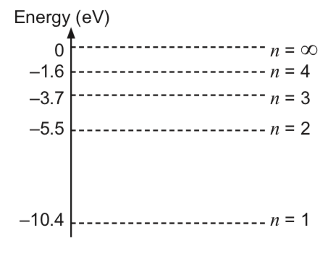

Indicate which one of the following transitions is the most energetic by circling it.

(1 mark)

*n* = 4 to *n* = 3 *n* = 2 to *n* = 1 *n* = 4 to *n* = 1

Determine the frequency and wavelength of the light emitted when the atom makes the most

energetic of the above transitions. (3 marks)

Frequency is Hz Wavelength is m

2. A light beam is directed toward a metal surface and electrons are ejected from it. The wavelength of the incident beam is varied between 238 nm (ultraviolet) and 464 nm (green). The maximum kinetic energy of the ejected photoelectrons is measured and recorded in the table below.

(a) Complete the following table by calculating the missing energy of the incident photons for each wavelength. Show your working in the space below. (2 marks)

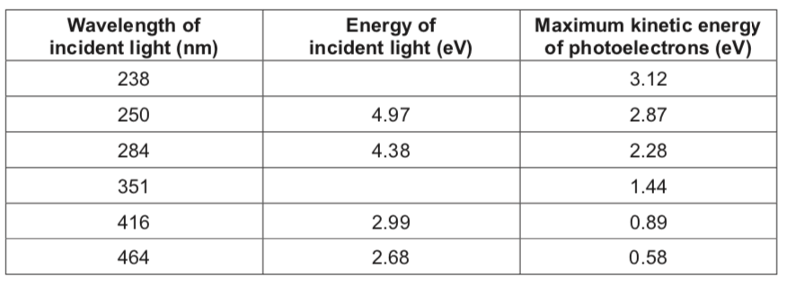

(b)   Plot the data from the table above on the grid provided, demonstrating the relationship between the energy of the incident photons on the horizontal axis and the maximum kinetic energy of photoelectrons on the vertical axis. Draw the line of best fit.

(4 marks)

(c)   Using your graph, determine the work function of the metal. Express your answer in appropriate significant figures and include units. (4 marks)



(d) Explain how the failure of red light to cause the emission of electrons demonstrates the

particle nature of light. (3 marks)

(e) In this photoelectric effect investigation, light is best described as a particle. There are other characteristics that demonstrate light to be a wave. State ***one*** such characteristic and describe how this demonstrates wave behaviour. (3 marks)

3. Silicon is a semi-conducting material commonly used to make photovoltaic cells.

Manufacturers of a solar-powered watch wanted to determine the work function of the silicon under low levels of artificial light. To test the solar-powered watch, the manufacturer used a light source which emitted photons with wavelengths of 510.6 nm and 578.2 nm.

The photoelectrons emitted were found to have a maximum kinetic energy of 5.36 × 10-20 J.

(a)   State why **all** photoelectrons emitted from the silicon do not have the same kinetic energy for a given incident wavelength. (1 mark)

(b)   Determine the maximum energy in joules of the highest energy incident photons.  
 (2 marks)

(c) Calculate the work function of the silicon in joules. (3 marks)

4. An experiment was conducted to investigate the nature of light. A parallel beam of monochromatic light was directed at a very small spherical object and a white screen was positioned behind the object (Diagram 1). The pattern observed on the white screen is shown in Diagram 2. (Note: diagrams not to scale.)

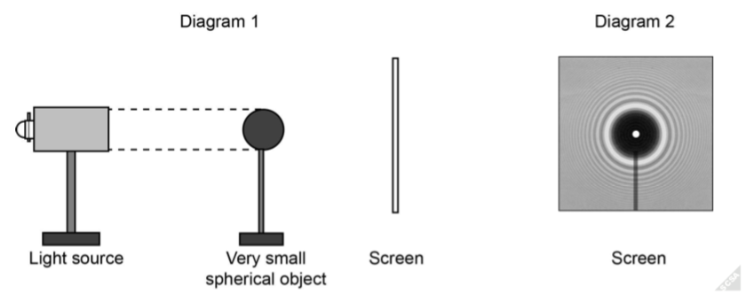

(a) Discuss how the pattern in Diagram 2 was produced. (5 marks)

(b) From this experiment, what conclusion can be made regarding the nature of light?  
 (1 mark)

5. An experiment was conducted to observe changes in colour and intensity as a bar of dull grey tungsten metal was heated from room temperature. When heated to 200 °C, the tungsten is observed as remaining grey and dull. When heated to 700 °C, the tungsten is observed as red and dull, and at 2700 °C, the tungsten is observed as white and bright.

(a) Describe why the colour and intensity of the tungsten changes as it is heated.

(2 marks)

(b) The tungsten is heated further until it starts melting at approximately 3400 °C. Use the axes below to sketch labelled graphs of intensity against wavelength for the two observed spectra at 2700 °C and 3400 °C. (3 marks)

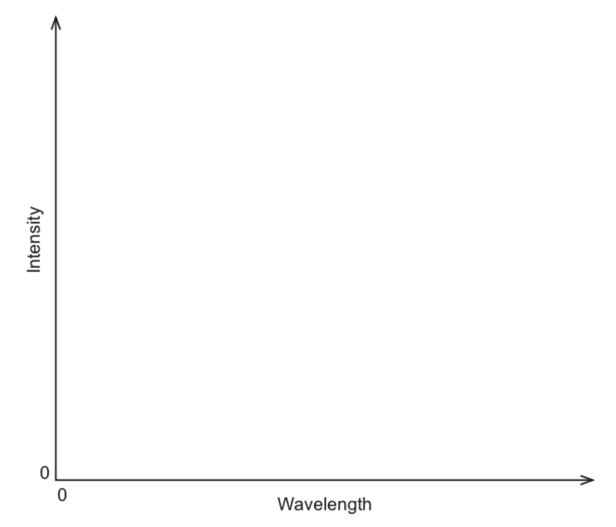

6. It is imagined that solar sails made from highly reflective thin sheets of metal might propel spacecraft on solar winds without the need for a propulsion system.

A space agency conducted an experiment to determine the possibility of propelling a spacecraft using a solar sail. To simulate the contribution of photons in solar wind, they used a highly collimated (focused) beam of light. This beam of light contained 2.50 × 1018 photons, with each photon having a wavelength of 487 nm. A highly-reflective mirror of mass 3.00 μg was used to simulate the solar sail. The collimated beam is fired at 90.0° to the surface of the highly-reflective mirror in a vacuum.

(a) Calculate the magnitude of the momentum of each photon. (2 marks)

When the photon beam collides with the mirror, momentum (equal to the product of mass and velocity) is conserved and the mirror moves.

(b) Calculate the recoil velocity of the mirror when the beam of light reflects from it.

(4 marks)

(c) Outline **two** possible limitations of using solar sail technology to propel a spacecraft.  
 (2 marks)

One:

Two:

7. A fluorescent light contains mercury vapour which is excited by an electric discharge from end to end inside the tube. This excitation causes some of the mercury atoms to ionise or produce high energy photons. These high energy photons then interact with the fluorescent material coating the inside of the tube to produce visible light.

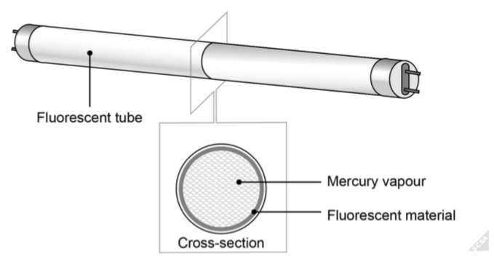

Some of the energy levels below the ionisation level for a mercury atom are shown in the energy level diagram below.

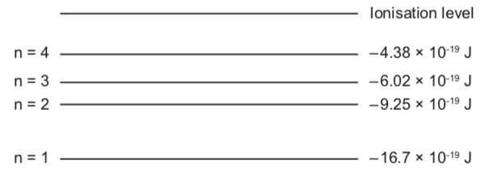

A photon with energy of 17.9 × 10-19 J collides with an electron in the ground state of a vaporised mercury atom.

(a) Calculate the velocity of any electron emitted from the ground state mercury atom.  
 (3 marks)

(b) Describe why some of the mercury atoms in the tube need to be ionised. (2 marks)

An electron with energy of 10.5 × 10-19 J collides with a ground state electron in a mercury atom.

(c) Calculate the possible energies the incident electron can have after this collision.  
 (3 marks)

(d) Determine the part of the spectrum to which the lowest energy emitted photons belong when subject to an incident electron with energy 10.5 × 10-19 J. (2 marks)

The photons emitted from the electron transition of the mercury atom then interact with the fluorescent material coating the inside of the tube.

(e) Explain how the emitted photons produced by the mercury atoms produce visible light in the fluorescent material. (3 marks)

8. An experiment was conducted to determine a value for Planck’s constant. The experiment

involved setting up five individual, single-frequency light emitting diodes (LEDs). Each LED only emits one frequency of light when a turn-on voltage (voltage above a certain threshold value) is applied across its terminals.

The relationship between the frequency of the emitted light and the voltage is given by the equation below.

*E* = *hf* = *qe*(*V0 + k*) where *h* is Planck’s constant

*f* is the frequency of light emitted by the diode

*qe* is the charge on an electron

*V0* is the turn-on voltage

*k* is the threshold voltage (constant dependent on the material)

The experiment produced the following results.

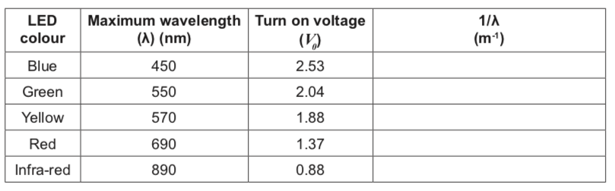

(a)   Complete the table above for values of 1/λ. (2 marks)

(b)   Plot a graph of voltage against 1/λ, with voltage on the y-axis, and draw a line of best fit. Error bars are not required. (5 marks)

(c)   Use the graph to calculate the gradient of the line of best fit. Show construction lines.  
 (3 marks)

(d) Use the gradient from part (c) and the provided equation to calculate a value for Planck’s constant. (3 marks)



(e) From your graph, determine the value for k in this experiment. (2 marks)

(f) Describe **two** possible sources of experimental error in the performance of this

experiment and how they might be modified to produce a more accurate result.

(4 marks)

One:

Two:

9. When light is shone on a metal plate, electrons may be emitted from the plate. This is called the ‘photoelectric effect’. The apparatus below shows incident light of wavelength 450 nm striking a metal plate. The number of photons striking the plate per second can also be controlled by varying the brightness of the incident light. The current produced by the light is initially measured by the ammeter (A). Initially, the ammeter (A) reads a current. The stopping potential (V) is then adjusted until the ammeter reads 0 A.

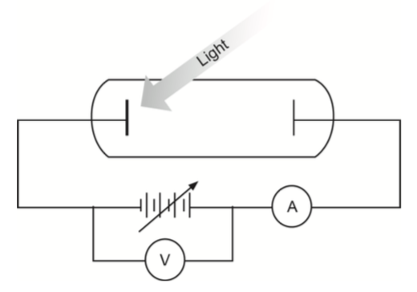

Assume the frequency of the light remains above the threshold frequency of the metal. In the table below, describe what would happen to the initial reading on A and the final reading on V, if the following changes were made. Use the terms ‘increase’, ‘decrease’ or ‘unchanged’.

(4 marks)

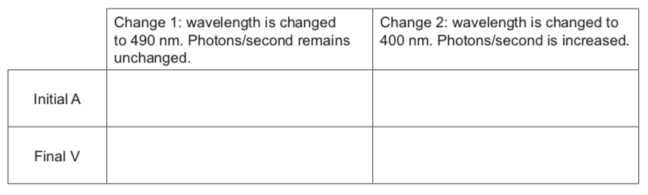

10. When gaseous mercury atoms are excited, they emit photons of varying wavelengths. Some of the energy levels in a mercury atom are shown in the diagram below.

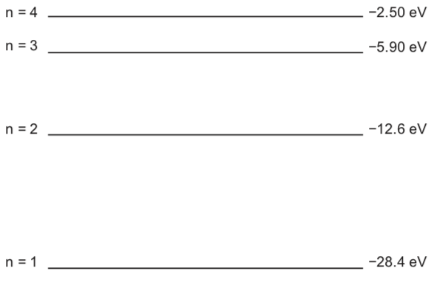

A mercury lamp is used to produce light which is first fed through a filter that eliminates all wavelengths except those produced from the n = 2 to n = 1 transition. The resultant light is then shone onto a potassium metal plate whose work function is 2.00 eV.

(a) On the diagram above, show all the possible downward electron transitions that can occur in a mercury atom after a successful collision with an incoming electron with an

energy of 23.0 eV. (4 marks)

(b) Calculate the wavelength of the photon from part (a) that strikes the potassium metal plate. (3 marks)

(c) Calculate the maximum velocity of any electrons liberated from the potassium metal plate. Ignore relativistic effects. (5 marks)

(d) State a formal definition of the term ‘work function’ and explain why part (c) refers to

maximum velocity. (3 marks)

11. The first serious challenge to the particle theory of light was made by the English scientist

Thomas Young in 1803. Young reasoned that if light were actually a wave phenomenon, as he suspected, then a similar interference effect observed with sound waves should occur for light. This line of reasoning led Young to perform an experiment which is nowadays referred to as ‘Young’s double-slit experiment’.

In Young’s double-slit experiment, two very narrow parallel slits, separated by a distance *d*, are cut into a plate made of thin metal. Monochromatic light, from a distant light source, passes through the slits and eventually hits an optical screen a comparatively large distance *L* from the slits. The experimental setup is shown in the diagram below.

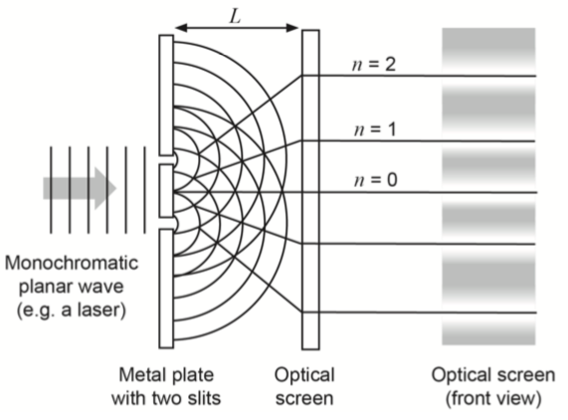

Young observed a series of alternating parallel light and dark bands on the screen, with the central band being bright. From his research, he established the following relationship between *L*, the distance between the slits and the screen; *d*, the distance between the two slits; *λ*, the wavelength of the monochromatic light and *x*, the distance between the centres of adjacent light bands in the interference patterns:

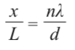

A group of students set up an experiment to measure the wavelength of light produced by a laser pointer. Using a commercially-produced metal plate where *d* = 2.19 × 10−5 m, they varied the distance from the slits to the optical screen (*L*) and measured the distance between the centre light band and the one closest to it (*n* = 1). Their results are shown in the table below.

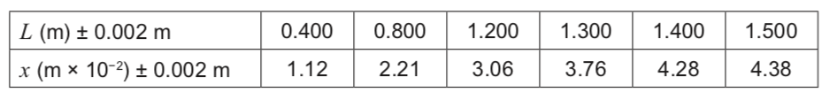

(a) Graph *x* vs *L* on the grid paper provided on page 23. Include the line of best fit. Do ***not***

include uncertainties. (5 marks)



(b)   From your graph, calculate the gradient of the line of best fit. Show construction lines on your graph. Use correct significant figures. (3 marks)

(c)   Using the gradient from part (b), calculate the wavelength of the monochromatic light used. Use correct significant figures. (4 marks)

The students were disappointed when they found their answer was 10% different from the wavelength supplied by the manufacturers of the laser pointer. When the teacher helped them use the uncertainties associated with their experiment, they found the manufacture’s value fell within the accepted range of uncertainty.

(d) Using the same values as in part (b), recalculate your gradient including uncertainties to show that a 10% difference falls within the accepted range. (5 marks)